Building PIP (Proactive Inspections Program) Update and Common Non-compliances
  - Q&A

The following answers have been provided to questions asked during the Building PIP (Proactive Inspections Program) Update and Common Non-compliances webinar on 28 September 2023.
The answers provided are correct as of 11 October 2023.

Where can I find a copy of the presentation slides?
A copy of the presentation slides and recording of the webinar are available from the VBA website.
Could the inspector contact the RBS on the day of/before/immediately after that an inspection is being carried out? This would help the RBS as some notifications come through well after, which may be an issue if a job has been plastered/bricked in the meantime.
The inspection is carried out as part of the PIP process in specific scenarios, however understanding this does not always prevent construction from continuing. Common practice is that the building inspections team will notify the builder/RBS via phone if non compliances are identified, if there is a likelihood of it being covered by plaster.
When would you mandate concreters to get registered? And isn't it a fault of the builder and or contractor workmanship, as well as compliance, where works are done after the mandatory stage. This should then go straight to the builder, and they should be directed to provide the required engineering for rectification.
In relation to the registration and licensing of trades, including concreters, you are encouraged to visit https://engage.vic.gov.au/registration-and-licensing-building-trades for the latest information and updates on this matter.
Furthermore, your insights on compliance issues are appreciated, especially those arising after the mandatory inspection stage. It's important to note that during our inspections, there may be ambiguities regarding the approval status of the mandatory stage or the previous reviews and approvals of any variations by the RBS. Given these complexities, our proactive inspection letters are often addressed to both the builder and the RBS. Should there be a determination that the building work is not in line with the building permit approval, we trust the RBS to undertake the appropriate enforcement actions to ensure these matters are addressed and resolved.

Aren’t the issues of honeycombing/cavitation an RBS’s responsibility? Unless obvious at frame stage.
If evident at the frame inspection stage, there is an expectation that the inspector will identify issues relating to honeycombing/exposed steel. That said, during construction, the builder shall have a duty of care in monitoring potential defects over the course of the build.
In what capacity does the RBS need to approve a remediation - i.e., is there a form that needs to be signed off or do they just need to be made aware of a remediation direction given by the PE designer?
Any proposed work out that differs from the design (architectural and engineering) that forms part of the building permit should be provided to the RBS for consideration and possible approval/inclusion as part of the building permit.
Should the frame inspection occur after plumbing, wiring, etc. services have been installed?
You're right in noting that the main goal of the mandatory frame inspection is to ensure compliance with the building permit. Currently, there's no obligation for builders to request further inspection after service installations. Your point highlights an area we might need to investigate for future regulatory adjustments.
Are we, as registered builders, able to request an inspection from the VBA at any point in a project, if we are faced with a building challenge that doesn't have an answer within NCC or builder surveyor etc?
The VBA is happy to assist with any technical questions you may have on a particular project. The RBS should be the main point of contact and can visit the site at any stage during construction to assist their clients.
Is it the responsibility of the mandatory building inspector to identify the incorrect installation of waterstops at a final inspection?
There is an expectation that during a final inspection, the building inspector will check that waterstop angles have been installed.
It is usually not possible at this time to ascertain whether a waterproof membrane has been installed as required - being covered by tiles and coatings. Waterstops and their intergration with the waterproofing system are difficult to visually inspect at final inspection. The new AS3740-2021 Clause 4.5.3 requires the membrane to be inspected prior to installing any overlying finish, however, this is not a mandatory inspection that is caused by the RBS. This is a duty of the builder and respective tradesperson to ensure it is adhered to.
Could you provide a breakdown of the most common (top 20) items found during class 1 proactive inspections?
The VBA publishes quarterly PIP reports that detail our most common items found during proactive inspections.
Is there a way that the standard for waterproofing detailed drawings should be included in all working drawings (WD) sets?
All working drawings must be adequately prepared to ensure compliance is demonstrated and will be achieved. The RBS must not issue a building permit unless satisfied with the building work and the building permit will comply with the Act and Regulations as per Section 24 of the Building Act 1993.

How do you properly seal bath lip to tiled podium?
Ensuring the correct sealing of bath lips, especially when adjacent to tiled podiums, is crucial for the longevity and functionality of the bathroom. The Australian Standard AS 3740 provides comprehensive guidance on this matter. Depending on the configuration of the bath and whether there's a shower over it, you'll find a variety of options. We would specifically direct your attention to Clause 4.13 of this standard for a detailed insight.
How close can we cut slab mesh next to the underground drains?
The Australian Standard AS 2870 outlines minimum concrete coverage requirements for both external and internal surfaces. However, it is essential to highlight the importance of referring directly to the structural engineering documentation. Specific projects may have design nuances, and the coverage requirements might vary accordingly.
I understand the curing of a slab should be 28 days, but this is never followed. Does this impact on the structural issues?
The 28-day curing period you mentioned is a commonly referenced duration for concrete to achieve approximately 90 per cent of its strength. While AS2870 outlines the curing performance criteria for aggressive soils (three days and seven days), for other situations, Clause 6.4.7 of AS 2870 states "the concrete shall be cured in accordance with good building practice".
That said, it's essential to understand that proper curing is crucial for the durability, strength, and overall performance of the concrete slab. Not adhering to recommended curing periods can indeed lead to potential structural issues or decreased longevity of the slab. Variations from the recommended curing time can impact shrinkage, strength development, and resistance to environmental factors.
We would encourage strict adherence to best practices and recommended curing durations to minimize potential risks and ensure the best outcome for your projects.
After mandatory frame inspection who would be accountable for holes & Fire Resistance Level (FRL) issues because of services installation?
For situations involving FRL (Fire Resistance Level) issues in Class 2, 3, or 4 buildings, it is anticipated that any non-compliances would be identified during the mandatory inspection stage, especially in instances of lightweight construction. We would direct you to regulation 172 for a comprehensive understanding of this matter.
In the context of Class 1 buildings, if penetrations and FRL issues arise post the mandatory frame inspection, it's crucial to note that, as of now, builders are not obligated to request further inspections after service installations.
Regarding accountability, it's essential to understand that various stakeholders have specific roles and responsibilities throughout the construction process. The primary onus lies with the builder to ensure that all work carried out adheres to approved plans, regulations, and quality standards. If holes or FRL issues emerge because of service installation after the mandatory frame inspection, the builder is usually held responsible for any rectifications required. Additionally, contractors or subcontractors who carried out the service installations may also share in this responsibility, especially if their work resulted in the noted issues.
Should all tilers undergo the waterproofing course and/or not be allowed to file unless they pass/learn what they should be doing?
As it stands, there is no existing requirement for tilers to hold a trade license. For any forthcoming updates or changes regarding licensing requirements, we encourage you to visit: https://engage.vic.gov.au/registration-and-licensing-building-trades for the most recent information
Do you have a video of installation of waterstop under cavity slider?
Unfortunately, we do not have a video on this topic at the moment. However, a detailed diagram addressing your question can be found in AS 3740. I'd recommend referring to Figure 4.9.1 (b), which illustrates the waterproofing at door opening cavity sliders.
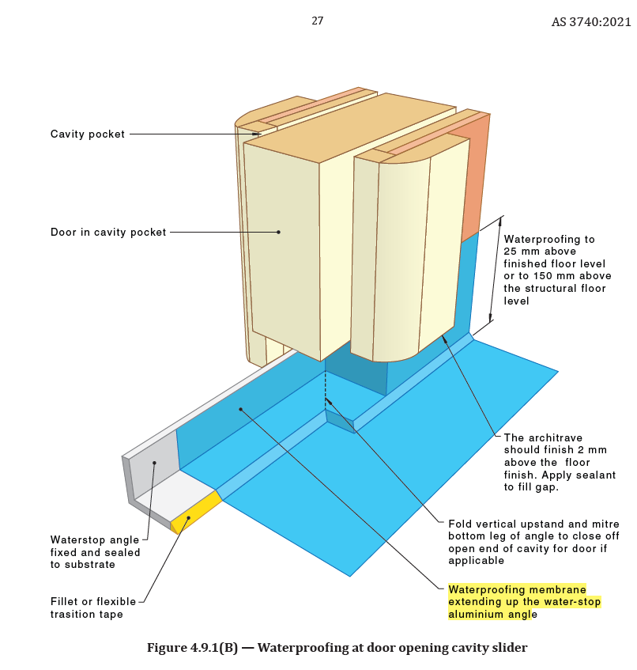

Why doesn’t a mandatory inspection occur at a crucial stage of a build? E.g., pre plastering and waterproofing?
Building Regulation 167 clearly outlines the specific stages of building work where mandatory notifications are required. These stages are:
- Prior to placing a footing;
- Before pouring an in situ reinforced concrete member, as specified in the relevant building permit by the relevant building surveyor;
- Upon completion of the framework;
- During any building work specified in the relevant building permit by the relevant building surveyor, in line with inspection requirements of regulation 172;
- Finally, upon the completion of all building work.
The regulations are designed to ensure that key structural and safety elements of the build are inspected and compliant. While stages such as pre-plastering and waterproofing are crucial for the quality and longevity of the build, they are not included as mandatory notification stages under the current regulation.
It's important to note that builders and contractors should always ensure best practices are followed at all stages of construction, even if they aren't specified as mandatory notification stages.We continuously seek feedback and aim to improve building regulations, so your concerns are valuable in shaping future iterations of these regulations.

For further information or clarification please contact the Technical and Regulation Team via technicalenquiry@vba.vic.gov.au

Copyright
© 2021 Victorian Building Authority (VBA). This publication must not be copied, reproduced, published, adapted, or communicated by any person without the VBA’s prior written consent or as permitted by the Copyright Act 1968 (Cth)
Disclaimer
The information set out in the VBA’s resources is for general information purposes and guidance only. It is a reader’s responsibility to obtain independent advice in respect of the application of legislation, a technical instruction or industry standard relevant to their circumstances. A person’s use of the VBA’s resources is not a substitute for obtaining independent advice.
While we have made every attempt to ensure our resources contain correct information at the date of publication, the VBA makes no warranty or representation that its resources are error free. To the extent permitted by applicable laws, the VBA, its employees, agents and consultants exclude any and all liability whatsoever for any direct, indirect, incidental, special or consequential loss or damage a person may suffer arising out of or in connection with the access and use of the VBA’s resources (including any third-party material included in these resources).

